Meals on Wheels setup

* Install Git kapag wala ka pa
  + Download url <https://git-scm.com/downloads>
* Install GitHub Desktop para di na tayo mag type ng mag type ng command sa cmd
  + Download url <https://desktop.github.com/>
* Cloning a repository

Sa URL tab paste lang yung repository url tas select nalang nag desired location mo kung san mo lalagay

Repository: <https://github.com/myaltithink/DEA-Project_Meals-on-Wheels.git>

* After cloning copy paste mo na yung **.env.example** na file tas rename mo lang sa **.env**

* Tas type ka ng command na **php artisan key:generate** para ma generate yung application key for encryption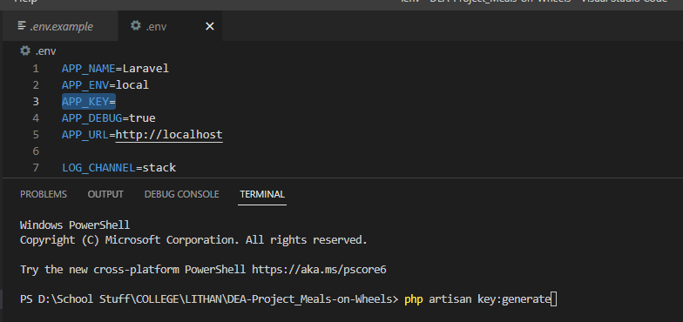

Pede mo na sya I run through **php artisan serve**